Jewelia England

CS 499

Enhancement One Software design and Engineering

August 15, 2024

**Full detailed instructions on how to use the artifact (A separate document).**

* Navigate to Run-> Run As -> Java Application
* Four input boxes will show up with the following to fill out:

Initial investment amount

Monthly deposit

Annual interest

Premium interest

Number of years

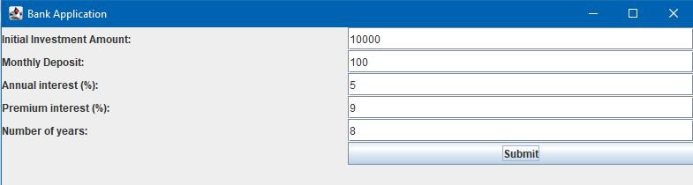

* Four graphs will be displayed:

Annual Interest over Months with Deposits

Annual Interest over Months with No Deposits

Monthly Closing Balance Over Time with Deposits

Monthly Closing Balance Over Time With No Deposits

